INDEX

SR NO | TITLE | PG NO | DATE | SIGN
1 | Installing and setting environment variables for Working with Apache Hadoop. | 2 | 11-08-23
2 | Implementing Map-Reduce Program for Word Count problem. | 8 | 18-08-23
3 | Download and install Spark. Create Graphical data and access the graphical data using Spark. | 13 | 25-08-23
4 | Write a Spark code to Handle the Streaming of data using RDD and Data frame. | 18 | 01-09-23
5 | Install Hive and use Hive Create and store structured databases. | 26 | 08-09-23
6 | Install HBase and use the HBase Data model Store and retrieve data. | 30 | 22-09-23
7 | Perform importing and exporting of data between SQL and Hadoop using Sqoop. | 34 | 29-09-23
8 | Write a Pig Script for solving counting problems. | 36 | 06-10-23

PRACTICAL NO:1

AIM: To Install Cloudera Quickstart VM on VirtualBox

Theory:
Cloudera is a software that provides a platform for data analytics, data warehousing, and machine learning. Initially, Cloudera started as an open-source Apache Hadoop distribution project, commonly known as Cloudera Distribution for Hadoop or CDH. It contains Apache Hadoop and other related projects where all the components are 100% open-source under Apache License.

Cloudera provides virtual machine images of complete Apache Hadoop clusters, making it easy to get started with Cloudera CDH. The following topics will be covered in this assignment on Cloudera QuickStart VM Installation.
- What is Cloudera QuickStart VM?
- Cloudera QuickStart VM Installation - Prerequisites
- Downloading the Cloudera QuickStart VM
- Cloudera QuickStart VM Installation on windows

What Is Cloudera QuickStart VM?
Cloudera QuickStart VM includes everything that you would need for using CDH, Impala, Cloudera Search, and Cloudera Manager. The Cloudera QuickStart VM uses a package- based install that allows you to work with or without the Cloudera Manager. It has a sample of Cloudera’s platform for “Big Data.”

Cloudera QuickStart VM Installation - Prerequisites
A virtual machine such as Oracle Virtual Box or VMWare
RAM of 12+ GB. That is 4+ GB for the operating system and 8+ GB for Cloudera 80GB hard disk

Download Oracle Virtual Box from https://www.virtualbox.org/wiki/Downloads and install it in your system

Downloading the Cloudera QuickStart VM
- The Cloudera QuickStart VMs are openly available as Zip archives in VirtualBox, VMware and KVM formats. To download the VM, search for https://www.cloudera.com/downloads.html, and select the appropriate version of CDH that you require.
- Click on the ‘GET IT NOW’ button, and it will prompt you to fill in your details.
- Once the file is downloaded, go to the download folder and unzip these files. It can then be used to set up a single node Cloudera cluster.
- Shown below are the two virtual images of Cloudera QuickStart VM.

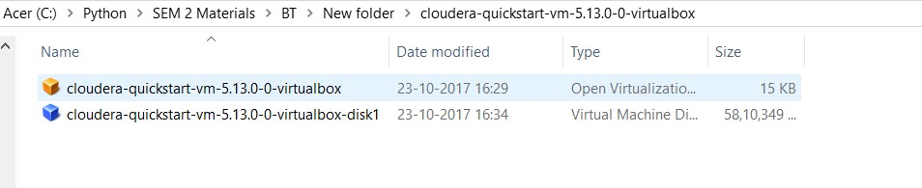

Now that the downloading process is done with, let's move forward with this Cloudera QuickStart VM Installation guide and see the actual process.
Cloudera QuickStart VM Installation
  - Before setting up the Cloudera Virtual Machine, you would need to have a virtual machine such as VMware or Oracle VirtualBox on your system.
  - In this case, we are using Oracle VirtualBox to set up the Cloudera QuickStart VM.
  - In order to download and install the Oracle VirtualBox on your operating system, click on the following link: Oracle VirtualBox(https://www.virtualbox.org/wiki/Downloads).
  - To set up the Cloudera QuickStart VM in your Oracle VirtualBox Manager, click on ‘File’ and then select ‘Import Appliance’.
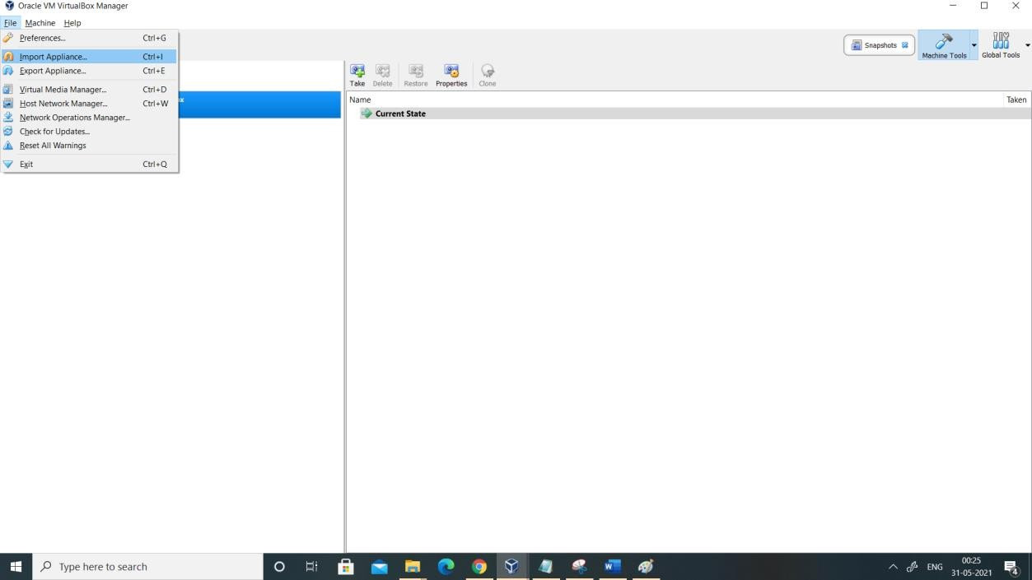

  - Choose the QuickStart VM image by looking into your downloads. Click on ‘Open’ and then ‘Next’. Now you can see the specifications, then click on ‘Import’. This will start importing the virtual disk image .vmdk file into your VM box.

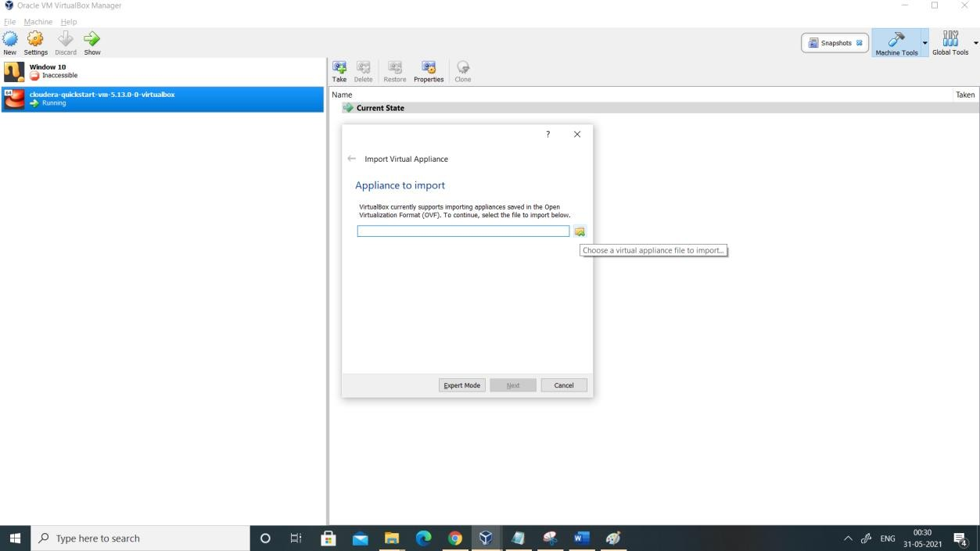
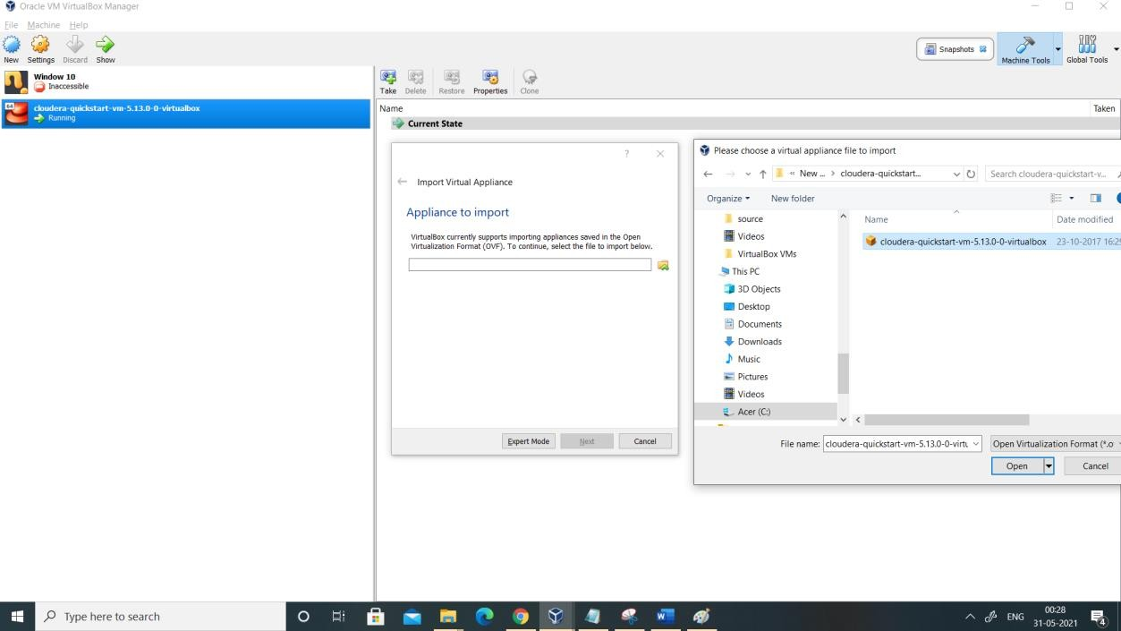

  - Click on "Open" and Wait for a while, as the importing finishes.
  - The next step is to go ahead and set up a Cloudera QuickStart VM for practice. Once the importing is complete, you can see the Cloudera QuickStart VM on the left side panel.

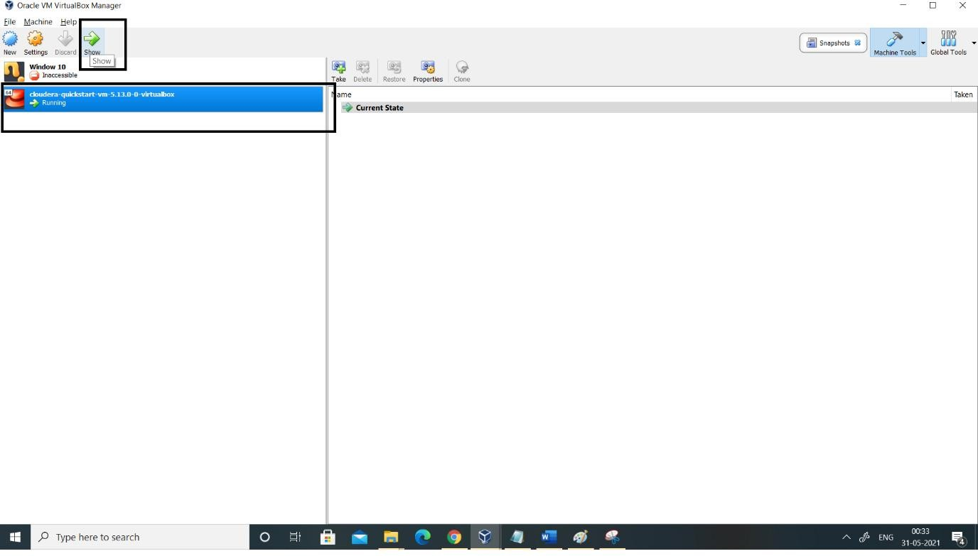
- The next step will be going ahead and starting the machine by clicking the ‘Start’
symbol on top.
- Once your machine comes on, it will look like this:


- Next, we have to follow a few steps to gain admin console access. You need to click on the terminal present on top of the desktop screen, and type in the following:

  - hostname # This shows the hostname which will be quickstart.cloudera
  - hdfs dfs -ls / # Checks if you have access and if your cluster is working. It displays what exists on your HDFS location by default
  - service cloudera-scm-server status # Tells what command you have to type to use cloudera express free
  - su - #Login as root
  - service cloudera-scm-server status # The password for root is cloudera

- Once you see that your HDFS access is working fine, you can close the terminal.
Then, you have to click on the following icon that says ‘Launch Cloudera Express’.

- Once you click on the express icon, a screen will appear with the following command:
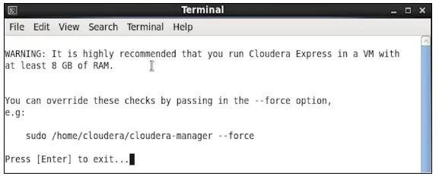
- You are required to copy the command, and run it on a separate terminal. Hence, open a new terminal, and use the below command to close the Cloudera based services. It will restart the services, after which you can access your admin console.
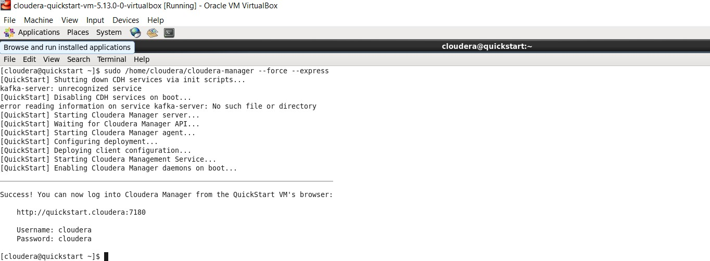

- Now that our deployment has been configured, client configurations have also been deployed. Additionally, it has restarted the Cloudera Management Service, which gives access to the Cloudera QuickStart admin console with the help of a username and password.

- Go on and open up the browser and change the port number to 7180.
- You can log in to the Cloudera Manager by providing your username and password.
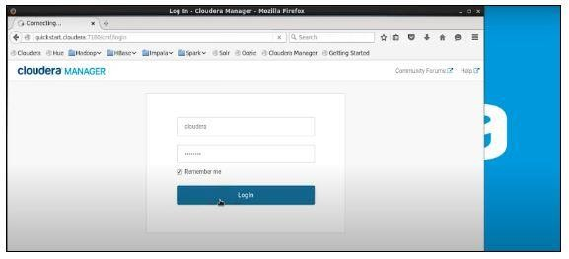
- You can go ahead and restart the services now. It will ensure that the cluster becomes accessible either by Hue as a web interface or Cloudera QuickStart Terminal, where you can write your commands.

PRACTICAL NO:2

AIM: Implementing Map-Reduce Program for Word Count Problem

Theory:
MapReduce is a programming model and processing framework designed for processing and generating large datasets that can be parallelized across a distributed cluster of computers. It was originally developed by Google and popularized by their 2004 paper titled "MapReduce: Simplified Data Processing on Large Clusters." MapReduce has been widely used in the big data processing field and has influenced the development of various distributed data processing systems, including Apache Hadoop.

MapReduce is designed to be fault-tolerant and scalable, making it suitable for processing large datasets across distributed clusters of commodity hardware. It abstracts away many of the complexities of distributed computing, allowing developers to focus on writing the mapping and reducing functions for their specific data processing tasks.

While MapReduce has been instrumental in the world of big data processing, more modern data processing frameworks like Apache Spark have gained popularity due to their improved performance and support for a broader range of data processing tasks. Nonetheless, MapReduce remains an important concept in the history of distributed data processing.

Steps to perform the practical:
Step1: Open Cloudera. Step2: Goto eclipse
Step3: Goto file>new>java project
Step4: Give name as WordCount, click on next and goto libraries click on add external jar
Step5: Goto file system>usr>lib>hadoop and select all the jar files and click on ok. Step6: Again, click add external jar> file system>usr>lib>hadoop>client and select all the jar files and click on ok.
Step7: Again, click add external jar> file system>usr>lib>hadoop>client0.20 and select all the jar files and click on ok.
Step8: click on finish
Step9: Under java project right click on src>new>class give name same as project name,click finish
Step10: Write the code for word count, cntl+s to save file import java.io.IOException;
import java.util.StringTokenizer;
import org.apache.hadoop.conf.Configuration; import org.apache.hadoop.fs.Path;
import org.apache.hadoop.io.IntWritable; import org.apache.hadoop.io.Text;
import org.apache.hadoop.mapreduce.Job; import org.apache.hadoop.mapreduce.Mapper;

import org.apache.hadoop.mapreduce.Reducer;
import org.apache.hadoop.mapreduce.lib.input.FileInputFormat; import org.apache.hadoop.mapreduce.lib.output.FileOutputFormat;

public class WordCount {
public static class TokenizerMapper extends Mapper<Object, Text, Text, IntWritable>
{
private final static IntWritable one = new IntWritable(1); private Text word = new Text();

public void map(Object key, Text value, Context context) throws IOException, InterruptedException {
StringTokenizer itr = new StringTokenizer(value.toString()); while (itr.hasMoreTokens()) {
word.set(itr.nextToken()); context.write(word, one);
}
}
}
public static class IntSumReducer extends Reducer<Text, IntWritable, Text, IntWritable> {
private IntWritable result = new IntWritable();

public void reduce(Text key, Iterable<IntWritable> values, Context context) throws IOException, InterruptedException {
int sum = 0;
for (IntWritable val : values) { sum += val.get();
}
result.set(sum); context.write(key, result);
}
}

public static void main(String[] args) throws Exception { Configuration conf = new Configuration();
Job job = Job.getInstance(conf, "wordcount"); job.setJarByClass(WordCount.class); job.setMapperClass(TokenizerMapper.class); job.setCombinerClass(IntSumReducer.class); job.setReducerClass(IntSumReducer.class); job.setOutputKeyClass(Text.class); job.setOutputValueClass(IntWritable.class); FileInputFormat.addInputPath(job, new Path(args[0])); FileOutputFormat.setOutputPath(job, new Path(args[1])); System.exit(job.waitForCompletion(true) ? 0 : 1);
}
}

Step11: Goto project name right click on it>export>java>jar file>click next >give path for jar file i.e cloudera, give name same as project name>click on>finish
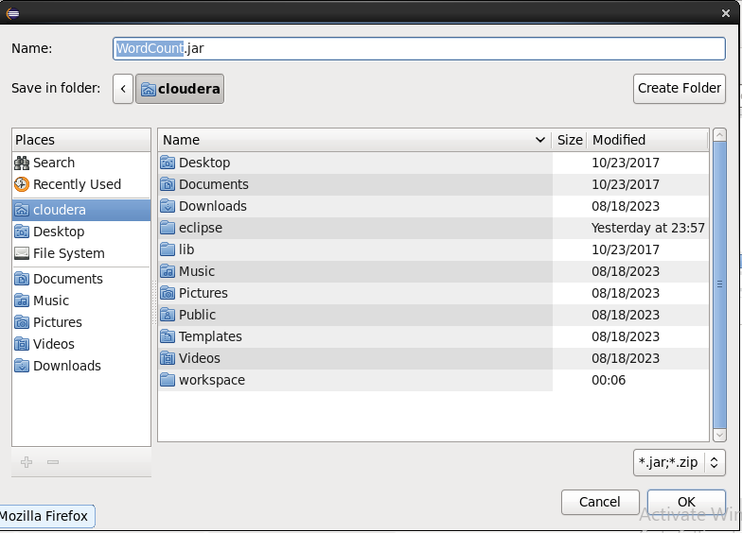

Step12: Goto cloudera home and check jar created or not.
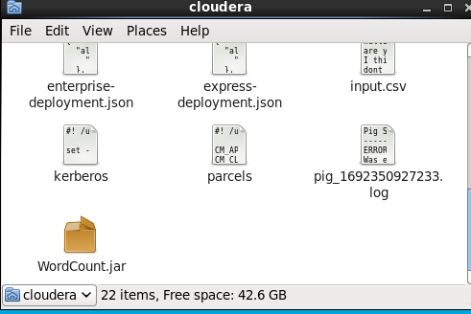

Step13: Open terminal fire ls command Step14: To check list of files under Hadoop. [cloudera@quickstart ~]$ hdfs dfs -ls Found 1 items
drwx------ - cloudera cloudera 0 2023-09-01 02:43 .staging

Step15: Create folder with name inputdirectory. [cloudera@quickstart ~]$ sudo -u hdfs hadoop fs -mkdir /mapreduce

Step16: To check folder created or not under Hadoop. [cloudera@quickstart ~]$ hdfs dfs -ls /
Found 8 items
drwxrwxrwx - hdfs supergroup 0 2017-10-23 10:29 /benchmarks
drwxr-xr-x - hbase supergroup 0 2023-09-29 23:23 /hbase
drwxr-xr-x - hdfs supergroup 0 2023-09-30 00:15 /mapreduce

Step17: Give permission to /inputdirectory folder.
[cloudera@quickstart ~]$ sudo -u hdfs hadoop fs -chmod -R 777 / mapreduce

Step18:To check permission granted or not under Hadoop. [cloudera@quickstart ~]$ hdfs dfs -ls /
Found 8 items
drwxrwxrwx - hdfs supergroup 0 2017-10-23 10:29 /benchmarks
drwxr-xr-x - hbase supergroup 0 2023-09-29 23:23 /hbase
drwxrwxrwx - hdfs supergroup 0 2023-09-30 00:15 / mapreduce

Step19: Check if directory contains any data (no output since directory is empty) [cloudera@quickstart ~]$ hdfs dfs -ls / mapreduce

Step20: Create file in local storage, enter content and cntrl+z [cloudera@quickstart ~]$ cat > /home/cloudera/input.txt This salma salma
^Z
[1]+ Stopped cat > /home/cloudera/Processfile1.txt

Step21: To check the content in Processfile1.txt [cloudera@quickstart ~]$ cat /home/cloudera/input.txt This salma salma

Step22: Transfer the file into hdfs from cloudera home
[cloudera@quickstart ~]$ sudo -u hdfs hadoop fs -put /home/cloudera/input.txt
/mapreduce

Step23: Check again if inputdirectory shows the file or not [cloudera@quickstart ~]$ hdfs dfs -ls /mapreduce
Found 1 items
-rw-r--r-- 1 hdfs supergroup 120 2023-09-30 00:22 /mapreduce/input.txt

Step24: Run the wordcount jar file
[cloudera@quickstart ~]$ hadoop jar /home/cloudera/WordCount.jar WordCount
/mapreduce/input.txt /mapreduce/output
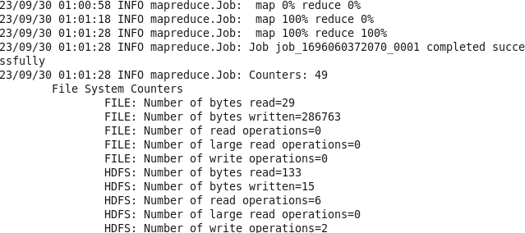

Step25: Check output folder
[cloudera@quickstart ~]$ hdfs dfs -ls /mapreduce/output
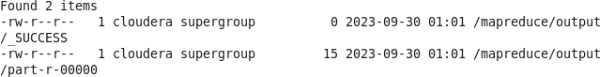

Step26: Check output result
[cloudera@quickstart ~]$ hdfs dfs -cat /mapreduce/output/part-r-00000

PRACTICAL NO:3

AIM: Download and install Spark. Create Graphical data and access the graphical data using Spark.
Theory:
Apache Spark is an open-source, distributed computing system that is designed for big data processing and analytics. It is a powerful framework for processing large volumes of data in parallel across a cluster of computers. Spark was developed to address some of the limitations of earlier big data processing frameworks like Hadoop MapReduce.

Apache Spark has gained widespread adoption in the big data and data analytics domain due to its speed, versatility, and ease of use. It is used by organizations for various data processing and analysis tasks, from batch processing large datasets to real-time data processing and machine learning applications.

Steps to perform the practical:
We will work on the below graph to understand the creation of graphical data and access of graphical data using spark.
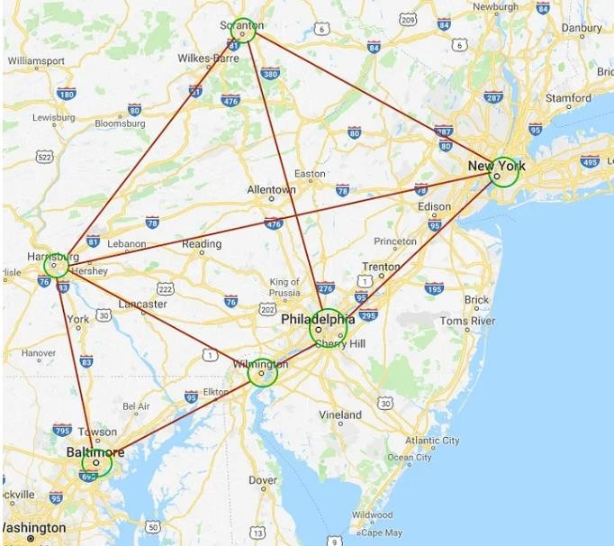
To work with above graph, we need to launch Spark shell.

Step1: Start Cloudera , type in the terminal:
spark-shell

Step2: Now, we have to make some imports:
import org.apache.spark.graphx.Edge #working with edge attribute

import org.apache.spark.graphx.Graph #analyzing and processing large graphs in a distributed fashion

import org.apache.spark.graphx.lib._ #Various analytics functions for graphs.

Step3: To create property graph we should firstly create an array of vertices and an array of edges. For vertices array, type in your spark shell:
val verArray = Array(
(1L, (“Philadelphia”, 1580863)),
(2L, (“Baltimore”, 620961)),
(3L, (“Harrisburg”, 49528)),
(4L, (“Wilmington”, 70851)),
(5L, (“New York”, 8175133)),
(6L, (“Scranton”, 76089)))
The attributes of the vertices mean the city name and population, respectively. As an output you will see the following:
verArray: Array[(Long, (String, Int))] = Array((1,(Philadelphia,1580863)),
(2,(Baltimore,620961)), (3,(Harrisburg,49528)), (4,(Wilmington,70851)), (5,(New York,8175133)), (6,(Scranton,76089)))

Step4: To create edges array, type in the spark shell:
val edgeArray = Array( Edge(2L, 3L, 113),
Edge(2L, 4L, 106),
Edge(3L, 4L, 128),
Edge(3L, 5L, 248),
Edge(3L, 6L, 162),
Edge(4L, 1L, 39),
Edge(1L, 6L, 168),
Edge(1L, 5L, 130),
Edge(5L, 6L, 159))

The first and the second arguments indicate the source and the destination vertices identifiers and the third argument means the edge property which, in our case, is the distance between corresponding cities in kilometres.

The above-mentioned input will give us the following output:
edgeArray: Array[org.apache.spark.graphx.Edge[Int]] = Array(Edge(2,3,113), Edge(2,4,106), Edge(3,4,128), Edge(3,5,248), Edge(3,6,162), Edge(4,1,39), Edge(1,6,168), Edge(1,5,130), Edge(5,6,159))
Step5: Next, we will create RDDs from the vertices and edges arrays by using the sc.parallelize()command:
Note: Resilient Distributed Dataset (RDD) is the fundamental data structure of Spark. They are immutable Distributed collections of objects of any type.
val verRDD = sc.parallelize(verArray) You will see:
verRDD: org.apache.spark.rdd.RDD[(Long, (String, Int))] = ParallelCollectionRDD[0] at
parallelize at <console>:34
val edgeRDD = sc.parallelize(edgeArray) You will see:
edgeRDD:org.apache.spark.rdd.RDD[org.apache.spark.graphx.Edge[Int]] = ParallelCollectionRDD[1] at parallelize at <console>:34

Step6: We are ready to build a property graph. The basic property graph constructor takes an RDD of vertices and an RDD of edges and builds a graph.
val graph = Graph(verRDD, edgeRDD) You will see:
graph: org.apache.spark.graphx.Graph[(String, Int),Int] = org.apache.spark.graphx.impl.GraphImpl@79ce6829

Step7: Let’s see some basic operations with graphs such as filtration by vertices, filtration by edges and operations with triplets.

- Filtration by vertices
To illustrate the filtration by vertices let’s find the cities with population more than
50000.

To implement this, we will use the filter operator: graph.vertices.filter {
case (id, (city, population)) => population > 50000
}.collect.foreach {
case (id, (city, population)) =>
println(s”The population of $city is $population”)
}

And this is the result we get:
The population of Scranton is 76089 The population of Wilmington is 70851
The population of Philadelphia is 1580863 The population of New York is 8175133 The population of Baltimore is 620961

- Triplets
One of the core functionalities of GraphX is exposed through the triplets RDD. There is one triplet for each edge which contains information about both the vertices and the
edge information. Let’s take a look through graph.triplets.collect.

As an example of working with triplets, we will find the distances between the connected cities:
for (triplet <- graph.triplets.collect) {
println(s”””The distance between ${triplet.srcAttr._1} and
${triplet.dstAttr._1} is ${triplet.attr} kilometers”””)
}

As a result, you should see:
The distance between Baltimore and Harrisburg is 113 kilometers The distance between Baltimore and Wilmington is 106 kilometers The distance between Harrisburg and Wilmington is 128 kilometers The distance between Harrisburg and New York is 248 kilometers The distance between Harrisburg and Scranton is 162 kilometers The distance between Wilmington and Philadelphia is 39 kilometers The distance between Philadelphia and New York is 130 kilometers The distance between Philadelphia and Scranton is 168 kilometers The distance between New York and Scranton is 159 kilometers

- Filtration by edges
Now, let’s consider another type of filtration, namely filtration by edges. For this purpose, we want to find the cities, the distance between which is less than 150 kilometers. If we type in the spark shell,

graph.edges.filter {
case Edge(city1, city2, distance) => distance < 150
}.collect.foreach {
case Edge(city1, city2, distance) =>
println(s”The distance between $city1 and $city2 is $distance”)
}

The result will be:
The distance between 2 and 3 is 113
The distance between 2 and 4 is 106
The distance between 3 and 4 is 128
The distance between 4 and 1 is 39
The distance between 1 and 5 is 130

PRACTICAL NO:4

AIM: Write a Spark code to Handle the Streaming of data using RDD and Data frame.

Theory:
Streaming data refers to a continuous flow of data that is generated, processed, and transmitted in real-time or near-real-time. Unlike traditional batch processing, where data is collected and processed in predefined chunks or batches, streaming data is constantly produced and processed as it becomes available. This data can come from various sources, including sensors, social media feeds, log files, financial transactions, and more.

RDD stands for Resilient Distributed Dataset, and it is a fundamental data structure in Apache Spark, a popular open-source distributed computing framework for big data processing. RDDs are designed to provide fault-tolerant, parallelized data processing capabilities in a distributed computing environment.

A DataFrame is a data structure commonly used in data analysis and manipulation, particularly in the Python programming language with libraries like Pandas. It is a two- dimensional, tabular data structure that resembles a spreadsheet or a SQL table. In a DataFrame, data is organized into rows and columns, where each column can contain data of different types, such as numbers, strings, or dates.

Software Requirements:
  - Apache Hadoop 3.3 or higher
  - Python 3.11 or higher
  - Java Development Kit (JDK) 8 or higher

Installation Procedure:
Step 1: Go to Apache Spark's official download page and choose the latest release. For
the package type, choose ‘Pre-built for Apache Hadoop’.
The page will look like the one below:
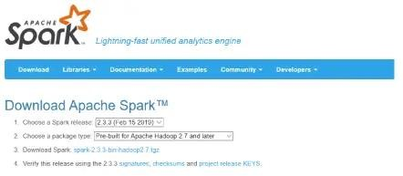

Step 2: Once the download is completed, unzip the file, unzip the file using WinZip or WinRAR, or 7-ZIP.
Step 3: Create a folder called Spark under your user Directory like below and copy and paste the content from the unzipped file.
C:\Users\<USER>\Spark
It looks like the below after copy-pasting into the Spark directory.
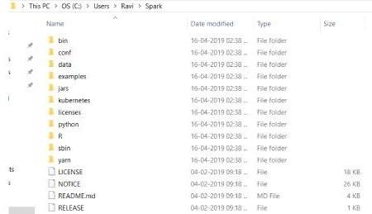

Step 4: Go to the conf folder and open the log file called log4j.properties. template. Change INFO to WARN (It can be an ERROR to reduce the log).

Step 5: Now, we need to configure the path.
Go to Control Panel -> System and Security -> System -> Advanced Settings -> Environment Variables
Add below new user variable (or System variable) (To add a new user variable, click on the New button under User variable for <USER>)
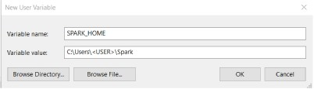

Click OK.
Add %SPARK_HOME%\bin to the path variable.
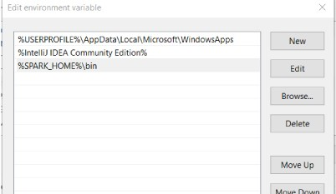
Click OK.

Step 6: Spark needs a piece of Hadoop to run. For Hadoop 3.3, you need to install winutils.exe.
You can find winutils.exe on this link https://github.com/steveloughran/winutils/tree/master You can download it for your ease.

Step 7: Create a folder called winutils in C drive and create a folder called bin inside. Then, move the downloaded winutils file to the bin folder.
C:\winutils\bin
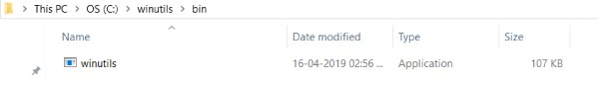
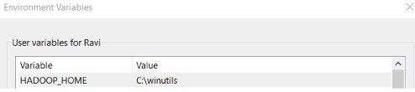
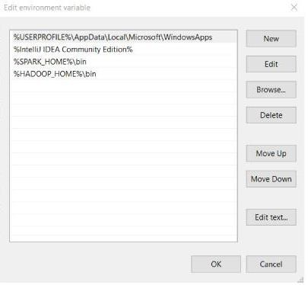
Add the user (or system) variable %HADOOP_HOME% like SPARK_HOME.

Click OK.

Step 8: To install Apache Spark, Java should be installed on your computer. If you don’t
have java installed on your system. Please follow the below process

Java Installation Steps:
- Go to the official Java site mentioned below the page. Accept Licence Agreement for Java SE Development Kit 8u201
- Download jdk-8u201-windows-x64.exe file
- Double Click on the Downloaded .exe file, and you will see the window is shown below.

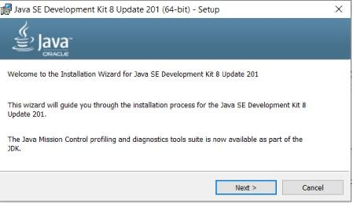

- Click Next.
- Then below window will be displayed.
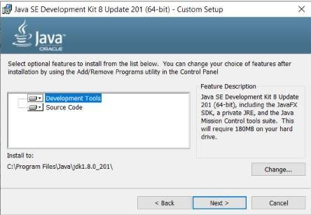

- Click Next.
- Below window will be displayed after some process.
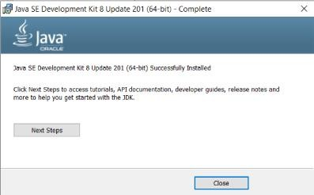

- Click Close.
Test Java Installation
Open Command Line and type java -version, then it should display the installed version of Java
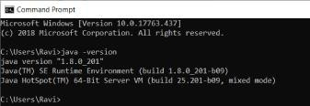

You should also check JAVA_HOME and the path of %JAVA_HOME%\bin included in user variables (or system variables)
1. In the end, the environment variables have 3 new paths (if you need to add a Java path, otherwise SPARK_HOME and HADOOP_HOME).
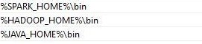

Test Installation
Open the command line and type spark-shell, and you will get the result below.
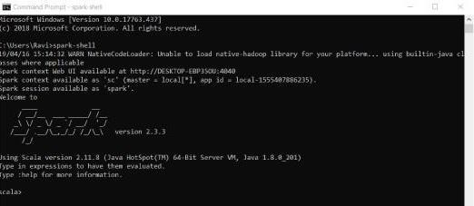

We have completed the spark installation on the Windows system. Creating and Accessing Graphical data in Spark:
Creating and accessing a bar graph in using pyspark:
To create a bar graph and access that bar graph in PySpark, you can use the Matplotlib library to create the bar graph and then use Spark to work with the data that you want to visualize in the bar graph. Here's a step-by-step guide:

- Install Dependencies:
You'll need to install both PySpark and Matplotlib if you haven't already. You can use pip for installation:
pip install pyspark pip install matplotlib

- Create a SparkSession:
Initialize a SparkSession to work with PySpark:
from pyspark.sql import SparkSession spark=SparkSession.builder.appName("BarGraphExample").getOrCreate()

- Prepare Data:
Prepare your data in a format that can be used to create a bar graph. For example, you can read data from a CSV file into a DataFrame:

from pyspark.sql import Row # Sample data
data = [Row(category="A", value=10), Row(category="B", value=20), Row(category="C", value=15), Row(category="D", value=30)]

# Create a DataFrame
df = spark.createDataFrame(data)

- Create the Bar Graph:
Use Matplotlib to create the bar graph based on the data in the DataFrame:

matplotlib.pyplot as plt
# Extract data from the DataFrame
categories = df.select("category").rdd.flatMap(lambda x: x).collect() values = df.select("value").rdd.flatMap(lambda x: x).collect()
# Create the bar graph plt.bar(categories, values) plt.xlabel("Categories") plt.ylabel("Values") plt.title("Bar Graph Example") # Display the graph plt.show()

This code will create a simple bar graph using Matplotlib and allow you to access and analyze your data using PySpark. You can customize the graph and data preparation based on your specific requirements and dataset.

- Access and Analyze Data:
You can still use Spark to perform operations on your data even after creating the bar graph. For example, you can use Spark to aggregate, filter, or manipulate the data and then update the bar graph accordingly.

Let's say you have a DataFrame with sales data for different product categories, and you've already created a bar graph. Now, you want to update the bar graph to show the total sales for each category and add a title to the graph. Here's an example:

from pyspark.sql import SparkSession import matplotlib.pyplot as plt

# Create a SparkSession Spark=SparkSession.builder.appName("BarGraphExample").getOrCreate() # Sample data

data = [("Electronics", 1000), ("Clothing", 1500),
("Books", 800)
("Toys", 1200)]

# Create a DataFrame
columns = ["Category", "Sales"]
df = spark.createDataFrame(data, columns)

# Create the initial bar graph
categories = df.select("Category").rdd.flatMap(lambda x: x).collect() sales = df.select("Sales").rdd.flatMap(lambda x: x).collect() plt.bar(categories, sales)
plt.xlabel("Categories") plt.ylabel("Sales")
plt.title("Bar Graph Example (Initial)")

# Display the initial graph plt.show()

# Continue data analysis
# Calculate total sales per category
total_sales = df.groupBy("Category").sum("Sales").withColumnRenamed("sum(Sales)", "TotalSales")

# Update the bar graph with total sales
updated_categories = total_sales.select("Category").rdd.flatMap(lambda x: x).collect() updated_sales = total_sales.select("TotalSales").rdd.flatMap(lambda x: x).collect()

# Create an updated bar graph with total sales plt.bar(updated_categories, updated_sales) plt.xlabel("Categories")
plt.ylabel("Total Sales")
plt.title("Bar Graph Example (Updated)")

# Display the updated graph plt.show()

- Close Spark Session:
Don't forget to stop the Spark session when you're done:
spark.stop()

In this example, we start by creating a bar graph that shows the initial sales data for each category. Afterward, we continue the data analysis using PySpark, calculate the

total sales for each category, and update the bar graph to display the total sales. The two bar graphs are displayed sequentially, showing the initial and updated data visualizations.

This demonstrates how you can use PySpark to perform data analysis, calculate new values, and update your visualizations accordingly.

PRACTICAL NO: 5

AIM: Install Hive and use Hive to Create and store structured databases.

Theory:
"Hive" refers to Apache Hive, which is an open-source data warehouse infrastructure and query language that is used for managing and querying large datasets stored in distributed storage systems like Hadoop Distributed File System (HDFS). Hive was originally developed by Facebook and later open-sourced as part of the Apache Software Foundation.

Apache Hive provides a high-level, SQL-like interface for working with big data in Hadoop clusters, making it easier for data analysts and engineers to access and analyze large datasets without the need for complex programming in MapReduce or other lower-level technologies.

Steps to perform the practical:
Step1: Start cloudera
Step2: Open new terminal and create cat file as [cloudera@quickstart ~]$ cat > /home/cloudera/employee.txt 1~Sachine~Pune~Product Engineering~100000~Big Data 2~Gaurav~Bengalore~Sales~90000~CRM 3~Manish~Chennai~Recruiter~125000~HR 4~Bhushan~Hyderabad~Developer~50000~BFSI

Step3: View the created file with cat command [cloudera@quickstart ~]$ cat /home/cloudera/employee.txt 1~Sachine~Pune~Product Engineering~100000~Big Data 2~Gaurav~Bengalore~Sales~90000~CRM 3~Manish~Chennai~Recruiter~125000~HR 4~Bhushan~Hyderabad~Developer~50000~BFSI

Step4: List all the file directory under HDFS [cloudera@quickstart ~]$ hdfs dfs -ls /
drwxrwxrwx - hdfs supergroup 0 2017-10-23 10:29 /benchmarks
drwxr-xr-x - hbase supergroup 0 2023-08-18 02:00 /hbase
drwxr-xr-x - solr solr 0 2017-10-23 10:32 /solr
drwxrwxrwt - hdfs supergroup 0 2023-08-18 02:12 /tmp
drwxr-xr-x - hdfs supergroup 0 2017-10-23 10:31 /user
drwxr-xr-x - hdfs supergroup 0 2017-10-23 10:31 /var

Step5: Create HDFS file directory with name inputdirectory [cloudera@quickstart ~]$ sudo -u hdfs hadoop fs -mkdir /inputdirectory

Step6: List the file directory to check if your directory has been created or not [cloudera@quickstart ~]$ hdfs dfs -ls /
drwxrwxrwx - hdfs supergroup 0 2017-10-23 10:29 /benchmarks
drwxr-xr-x - hbase supergroup 0 2023-08-18 02:00 /hbase
drwxr-xr-x - hdfs supergroup 0 2023-08-25 02:14 /inputdirectory
drwxr-xr-x - solr solr 0 2017-10-23 10:32 /solr
drwxrwxrwt - hdfs supergroup 0 2023-08-18 02:12 /tmp
drwxr-xr-x - hdfs supergroup 0 2017-10-23 10:31 /user
drwxr-xr-x - hdfs supergroup 0 2017-10-23 10:31 /var [cloudera@quickstart ~]$

Step7: Give the permission of read, write and execution to the input directory [cloudera@quickstart ~]$ sudo -u hdfs hadoop fs -chmod -R 777 /inputdirectory

Step8:Check if the permissions has been granted to your directory or not, you will see drwxrwxrwx for your directory if it has been granted
[cloudera@quickstart ~]$ hdfs dfs -ls /
drwxrwxrwx - hdfs supergroup 0 2017-10-23 10:29 /benchmarks
drwxr-xr-x - hbase supergroup 0 2023-08-18 02:00 /hbase
drwxrwxrwx - hdfs supergroup 0 2023-08-25 02:14 /inputdirectory
drwxr-xr-x - solr solr 0 2017-10-23 10:32 /solr
drwxrwxrwt - hdfs supergroup 0 2023-08-18 02:12 /tmp
drwxr-xr-x - hdfs supergroup 0 2017-10-23 10:31 /user
drwxr-xr-x - hdfs supergroup 0 2017-10-23 10:31 /var

Step9: Now, shift the file which you have created earlier with cat command from cloudera to HDFS directory
[cloudera@quickstart ~]$ sudo -u hdfs hadoop fs -put /home/cloudera/employee.txt
/inputdirectrory

Step10: View the inputdirectory whether your file has been added or not [cloudera@quickstart ~]$ hdfs dfs -ls /inputdirectrory
-rw-r--r-- 1 hdfs supergroup 165 2023-08-25 02:21 /inputdirectrory/employee.txt

Step11: Read file in HDFS as,
[cloudera@quickstart ~]$ hadoop fs -cat /inputdirectrory/employee.txt 1~Sachine~Pune~Product Engineering~100000~Big Data 2~Gaurav~Bengalore~Sales~90000~CRM 3~Manish~Chennai~Recruiter~125000~HR 4~Bhushan~Hyderabad~Developer~50000~BFSI

Step12: Now enter into hive shell to create and store structured data [cloudera@quickstart ~]$ hive
hive>

Step13: List all the databases present under hive hive> show databases;
OK
default

Step14: Create database named organization hive>create database organization;
OK

Step15: Check if database has been created or not hive> show databases;
OK
default organization

Step16: Change database from default to organization hive> use organization;
OK

Step17: Create table named employee hive> create table employee(
- id int,
- name string,
- city string,
- department string,
- salary int,
- domain string)
- row format delimited
- fields terminated by '~';
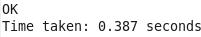

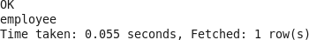
Step18: List all the tables to check whether your table has been created or not hive>show tables;

Step19: Read content from employee table, nothing will be printed because only columns has been created without data
hive> select * from employee;

Step20: Load the employee data from HDFS to employee table
hive>load data inpath '/inputdirectory/employee.txt' overwrite into table employee;
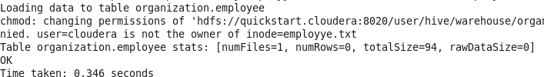

Step21: Read the content of employee table again,this time you will get the data because we have shifted the data from HDFS to employee table
hive>show tables;
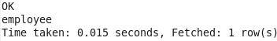

hive>select * from employee;
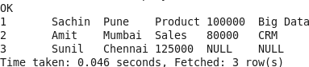

PRACTICAL NO: 6

AIM: Install HBase and use the HBase Data model to store and retrieve data

Theory:
HBase is a distributed, scalable, and open-source NoSQL database system designed to handle large amounts of data in a distributed computing environment. It is part of the Apache Hadoop ecosystem and is often used for managing and storing vast amounts of semi-structured or unstructured data.

HBase is a valuable tool in the big data landscape, offering a distributed and scalable solution for managing and querying large volumes of data with low-latency requirements. It is particularly well-suited for use cases where traditional relational databases may struggle to handle the scale and complexity of the data.

Steps to perform the practical:
Step1: Start Cloudera
Step2: start the hbase shell as:
[cloudera@quickstart ~]$ hbase shell hbase(main):001:0>

Step3: Check status,version,table_help, whoami hbase(main):001:0> status
1 active master, 0 backup masters, 1 servers, 0 dead, 2.0000 average load

hbase(main):002:0> version
1.2.0-cdh5.13.0, rUnknown, Wed Oct 4 11:16:18 PDT 2017

hbase(main):003:0> table_help Help for table-reference commands.

hbase(main):004:0> whoami cloudera (auth:SIMPLE)
groups: cloudera, default

Step4: Create table employee
hbase(main):005:0> create 'employee','Name','ID','Designation','Salary','Department' 0 row(s) in 1.3730 seconds
=> Hbase::Table - employee

Step5: Verify if table is created or not hbase(main):006:0> list
TABLE
employee

=> ["employee"]

Step6:Disable the table employee hbase(main):007:0> disable 'employee' 0 row(s) in 2.3730 seconds

Step7:Scan the table employee hbase(main):008:0> scan 'employee' ROW COLUMN+CELL
ERROR: employee is disabled.
Step8: Check if table employee is disabled or not hbase(main):010:0> is_disabled 'employee' true
- row(s) in 0.0250 seconds

Step9:Try to disable all the table starting with letter e hbase(main):011:0> disable_all 'e.*'
employee

Disable the above 1 tables (y/n)? y
- tables successfully disabled

Step10: Enable the employee table again hbase(main):012:0> enable 'employee' 0 row(s) in 1.2720 seconds

Step11: Check if employee table is enabled or not hbase(main):013:0> is_enabled 'employee'
true
0 row(s) in 0.0220 seconds

Step12: Create new table student
hbase(main):014:0> create 'student','name','age','course' 0 row(s) in 1.2410 seconds
=> Hbase::Table - student hbase(main):015:0>

Step13: Insert two students data into the student table
hbase(main):015:0> put 'student','sharath','name:fullname','sharath kumar' 0 row(s) in 0.0490 seconds

hbase(main):016:0> put 'student','sharath','age:presentage','24' 0 row(s) in 0.0060 seconds

hbase(main):017:0> put 'student','sharath','course:pursuing','Hadoop' 0 row(s) in 0.0030 seconds

hbase(main):018:0> put 'student','shashank','name:fullname','shashank kamble' 0 row(s) in 0.0050 seconds

hbase(main):019:0> put 'student','shashank','age:presentage','23' 0 row(s) in 0.0020 seconds

hbase(main):020:0> put 'student','shashank','course:pursuing','Java' 0 row(s) in 0.0030 seconds

Step14: Try to retrieve the students data from table student hbase(main):022:0> get 'student','shashank'
COLUMN CELL
age:presentage timestamp=1693559656275, value=23 course:pursuing timestamp=1693559672356, value=Java name:fullname timestamp=1693559641013, value=shashank kamble

hbase(main):023:0> get 'student','sharath' COLUMN CELL
age:presentage timestamp=1693559577914, value=24 course:pursuing timestamp=1693559608940, value=Hadoop name:fullname timestamp=1693559511147, value=sharath kumar

hbase(main):024:0> get 'student','sharath','course' COLUMN CELL
course:pursuing timestamp=1693559608940, value=Hadoop

hbase(main):025:0> get 'student','shashank','course' COLUMN CELL
course:pursuing timestamp=1693559672356, value=Java

hbase(main):026:0> get 'student','sharath','name' COLUMN CELL
name:fullname timestamp=1693559511147, value=sharath kumar

hbase(main):027:0> get 'student','sharath','age' COLUMN CELL
age:presentage timestamp=1693559577914, value=24

Step15: Scan and count the student table hbase(main):028:0> scan 'student' ROW COLUMN+CELL

sharath column=age:presentage, timestamp=1693559577914, value=24 sharath column=course:pursuing, timestamp=1693559608940, value=Hadoop
sharath column=name:fullname, timestamp=1693559511147, value=sharath kumar
shashank column=age:presentage, timestamp=1693559656275, value=23 shashank column=course:pursuing, timestamp=1693559672356, value=Java shashank column=name:fullname, timestamp=1693559641013, value=shashank kamble
hbase(main):029:0> count 'student' 2 row(s) in 0.0150 seconds

Step16:Try to alter the student table
hbase(main):042:0> alter 'student',NAME=>'name',VERSION=>5

Step17: Put the altered value as:
hbase(main):043:0> put 'student','shashank','name:fullname','shashank rao' 0 row(s) in 0.0030 seconds

Step18: Scan student and check if name is altered or not hbase(main):044:0> scan 'student'
ROW COLUMN+CELL
sharath column=age:presentage, timestamp=1693559577914, value=24 sharath column=course:pursuing, timestamp=1693559608940, value=Hadoop
sharath column=name:fullname, timestamp=1693559511147, value=sharath kumar
shashank column=age:presentage, timestamp=1693559656275, value=23
shashank column=course:pursuing, timestamp=1693559672356, value=Java
shashank column=name:fullname, timestamp=1693560273772, value=shashank rao

Step19: Delete the column name of student shashank hbase(main):045:0> delete 'student','shashank','name:fullname' 0 row(s) in 0.0250 seconds

Step20: Check if the name column has been deleted or not hbase(main):046:0> get 'student','shashank'
COLUMN CELL
age:presentage timestamp=1693559656275, value=23 course:pursuing timestamp=1693559672356, value=Java

PRACTICAL NO:7

AIM: Perform importing and exporting of data between SQL and Hadoop using Sqoop

Theory:
Sqoop is a tool commonly used in the context of Big Data to facilitate the transfer of data between Apache Hadoop and relational databases. The name "Sqoop" is a combination of "SQL" (Structured Query Language) and "Hadoop." Sqoop is designed to simplify the process of importing data from a relational database (such as MySQL, Oracle, or SQL Server) into Hadoop and exporting data from Hadoop back to a relational database.

Steps to perform the practical:
Step 1: Open terminal and type the below common to connect to mysql [cloudera@quickstart ~]$ mysql -D retail_db -u retail_dba -p
Enter password: cloudera mysql>

Step2: List the table in mysql mysql> show tables;
+---------------------+
| Tables_in_retail_db |
+---------------------+
| categories |
| customers |
| departments |
| order_items |
| orders |
| products |
+---------------------+
6 rows in set (0.00 sec)

Step3: Select the data from customers table mysql> select * from customers;

12435 rows in set (0.01 sec)

Step4: Open new terminal and type below command
[cloudera@quickstart ~]$ sqoop import --connect jdbc:mysql://localhost/retail_db -- table customers --username retail_dba --password cloudera --target-dir
/sqoop_import_data -m 1

Step5: View if data has been transferred from sql to hadoop or not [cloudera@quickstart ~]$ hadoop fs -cat /sqoop_import_data/part-m-00000
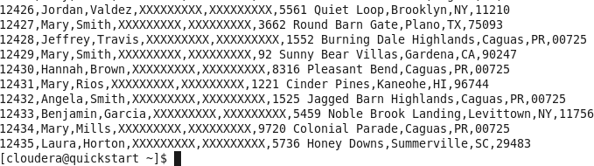

PRACTICAL NO:8

AIM: Write a Pig Script for solving counting problems.

Theory:
Apache Pig is a platform and high-level scripting language designed to simplify the process of writing complex data processing tasks for large datasets in a Hadoop ecosystem. It was developed by Yahoo! and later became an open-source project under the Apache Software Foundation.

Apache Pig provides a way to express data transformations and analysis in a more abstract, SQL-like language called Pig Latin. Pig Latin scripts are then compiled into a series of MapReduce jobs, which can be executed on a Hadoop cluster. This abstraction helps data analysts and engineers work with large datasets more easily without having to write low-level MapReduce code.

Steps to open the Cloudera:
Step1: Open Vmware workstation and drag the cloudera file in vmware Step2: Click on Cloudera manager if it doesn’t opens then do the step 3 Step3: Click on Launch Cloudera Express and copy the sudo code listed there.
Step4: Open the new terminal, paste the copied code followed with - - express and press enter. After it’s executed, you will get the username and password, go to cloud manager again and it will now ask for username and password.
Step5: Enter username and password. Once it is done you are good to go for practical execution.

Steps to perform the practical:
Step1: Open the new terminal and create one file csv as input.csv [cloudera@quickstart ~]$ cat > /home/cloudera/input.csv hello...How are you?
are you okay?
I think need some break. dont overthink
you can do it
You and I are best friends

Step2: After writing the code enter cntl+z to exit. Then view the data as: [cloudera@quickstart ~]$ cat /home/cloudera/input.csv
hello...How are you? are you okay?
I think need some break. dont overthink
you can do it

Step3: To view the data through pig enter into the pig shell. [cloudera@quickstart ~]$ pig -x local

Step4: After the above command your prompt will change into (grunt>)
Step5: Enter the below code to get the word count of your file grunt> lines = load '/home/cloudera/input.csv' as (line:chararray);
grunt>words = foreach lines GENERATE FLATTEN(TOKENIZE(line)) as woed; grunt> grouped = GROUP words by woed;
grunt> wordcount = foreach grouped GENERATE group, COUNT(words); grunt> dump wordcount;

Step6: Once you enter after writing the above code you will see the output as: (I,1)
(do,1)
(it,1)
(are,2)
(can,1)
(you,2)
(dont,1)
(need,1)
(some,1)
(you?,1)
(okay?,1)
(think,1)
(break.,1) (overthink,1) (hello...How,1)

